**Automatic Door Lock System**

COVID-19 it is a life killing virus, which spreads primarily through touching thing, And opening/closing of a door is one the main thing that every individual do in there daily life which also increases the chances of spreading of coronavirus.

So, here we have the solution for this

It is an automatic Door lock System which helps, in preventing form Coronavirus(COVID-19)

in hospitals, any other public places or even in your home.

**Working:**

The producer of accessing the door is,

1. it senses the person who wants to open the door, using the ultrasonic sensor

2. it checks the temperature of the individual, if he/she has a temperature more then the 38-degree celsius, then he/she was not able to open the door and it gives the red light alert, he/she has the high chances of coronavirus.

3. if a person has less temperature, then it has to go through the sanitization which sprays the sanitization in there all body, Which also decreases the chances of spreading of coronavirus

4. The second way of spreading of coronavirus is by touching, After you done with all the producers of door, it will automatically open for you. You don't have to touch it. which again help us in preventing from the coronavirus

And is all producer done within 5-8 seconds

The door lock can also connect from the mobile phone using the Bluetooth, and you can also access it by using it, but it is only for the main members of the hospitals

**Why this:**

We have the 3 main features in our Door lock System that can help us in preventing from coronavirus(COVID-19).

1. **Automatic Door open:** 90% of spreading of this virus is from the touching thing, And opening and Closing of a door is the main thing that we do in our daily life which increases the chances of spreading it. So, here we have the solution for this, an automatic door lock

2. **Temperature scanning of a person:** We have some additional features on it like, scanning of a temperature of a person, and if he/she has a temperature more then 38-degree celsius then we have the next phase. which is the spreading of sanitizer.

3. **The spray of sanitizer:** it is the last phase, whichever person has to pass through, which is spray or sanitizer it can be of full body spray or hand spray only, without pass through no one can go through the door.

- this door is very use full in our hospital and any busy places like the airport or any public places

**Sensor and Components Used:**

1. (mlx90614) IR temperature Sensor

2. (HC-sr04) Ultrasonic sensor

3. Arduino

4. (HC-06) Bluetooth

5. (L298N 2A)Motor controllor

6. DC / Servo Motors

**Circuit Digram :**

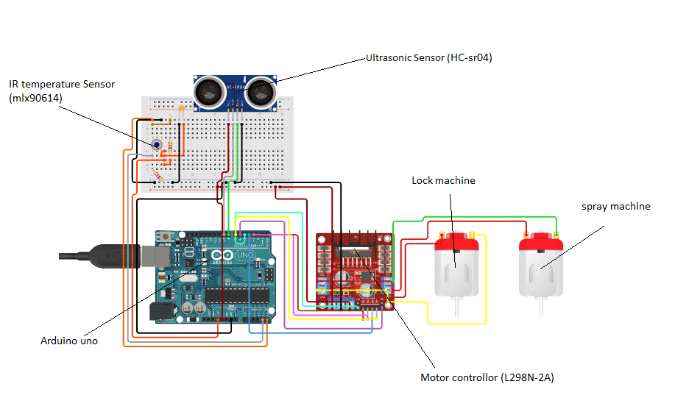

**How it look in door :**

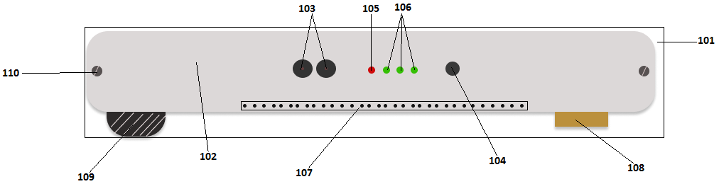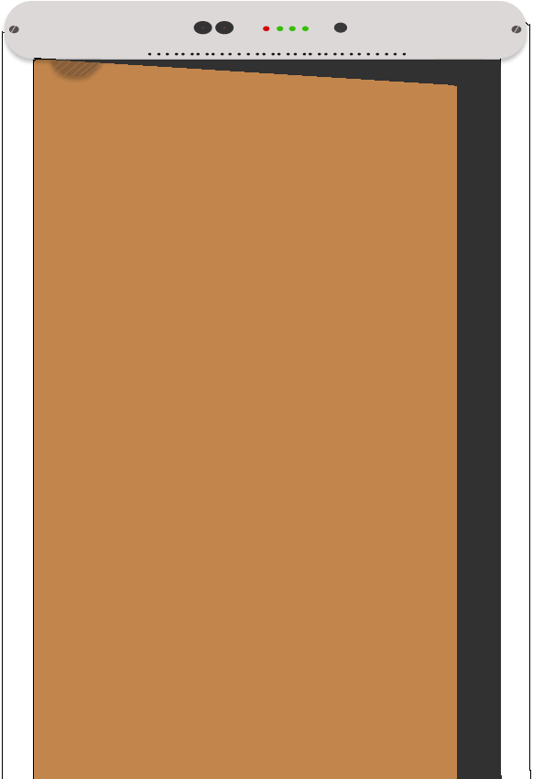

**Mobile Application :**

